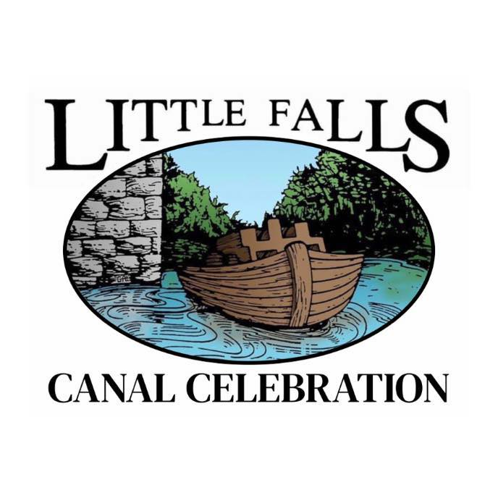

**Eastern Park Craft Fair and Farmer’s Market**

**August 9th-11th, 2024**

Greetings!

Thank you for your interest in participating in the 2024 Little Falls Canal Celebration! This festival is a weeklong celebration that includes many events throughout our beautiful city. A very popular event is the Craft Fair and Farmer’s Market that takes place over the weekend. Vendors have the option of setting up on Friday, August 9th in the afternoon. Friday evening at 6pm is the parade and 3-3 basketball tournament that is within walking distance to the park. Many people wander up to the park afterwards to check out craft and food vendors. Most of the traffic will be on Saturday and Sunday. The park is open from 10am until 5pm on Saturday and until 4pm on Sunday.

If you will be setting up on Saturday morning, we ask that you arrive any time after 8:00am to get unloaded and setup before the park opens. Please report to the Eastern Park registration table for your space allocation. We will be giving a 12’ x 12’ space to each participant. Please make your check or money order payable to Little Falls Canal Celebration. You will be sent a confirmation and directions to Little Falls.

If accommodations are needed, there is a hotel in town along with numerous B&Bs.

Please contact Cathy Cristman if you have any questions at (315) 868-3248 or [hysack04@yahoo.com](mailto:hysack04@yahoo.com). We look forward to meeting you, and to a successful and prosperous weekend!

Thank you.

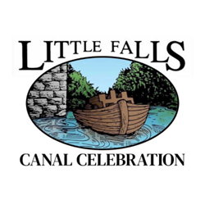

Little Falls Canal Celebration

C/O Little Falls Youth and Family Center

15 Jackson St

Little Falls, NY 13365

**Exhibitors/Vendors Application**

**August 9th, 10th, & 11th, 2024**

Hours:

Friday: 2pm-10pm

Saturday: 10am-5pm

Sunday: 10am-4pm

Name:_________________________ Business Name:_______________________________

Address:_______________________City:_________________State:________Zip:________

Phone Number:_________________

Email Address:______________________________________

Please select proper classification:

______Arts & Crafts (Type:_________) ______Farmer/Flea Market (Type:________)

______Food (Type:_________)

Booth Size is 12 x 12: Any tents or setups larger must purchase 2 spaces

_______Friday, Saturday, & Sunday $60

_______Saturday & Sunday only $40

_______Food Vendors $100

Exhibitors must provide all display materials (inc. tables). You are responsible for your own booth cover also. Exhibitors may not dismantle their booths until 4pm on Sunday. Participants must staff their own booths.

**Application Deadline: July 26th 2024**

We reserve the right to deny any application because of duplication of services already provided or inappropriate items for a family friendly event. The Canal Celebration committee reserves the right to have the final decision of immediate removal. In consideration of the acceptance of this application to participate in “The Little Falls Canal Celebration” exhibitors/vendors display indicated above, I hereby release and discharge the State of New York, County of Herkimer, City of Little Falls, and The Little Falls Canal Celebration Committee” of any and all claims for loss, damage or injury arising out of my participation in the event.

Date:______________________ Signature:________________________________________________

**Contact Person: Cathy Cristman 315-868-3248 or hysack04@yahoo.com**